Budget Estimation Software : Creating local https certificate for ams. Please follow below steps to generate this, this is only valid for One year. So you need to update it yearly or just buy one.

**Blog Link**

**https://devblogs.microsoft.com/aspnet/configuring-https-in-asp-net-core-across-different-platforms/**

**https://docs.microsoft.com/en-us/powershell/module/pkiclient/new-selfsignedcertificate?view=win10-ps**

**How to create a HTTPS certificate to your server and local machine?**

Just run **dotnet dev-certs https –trust**

## Then Trust the certificate

This step is optional, but without it the browser will warn you about your site being potentially unsafe. You will see something like the following if you browser doesn’t trust your certificate

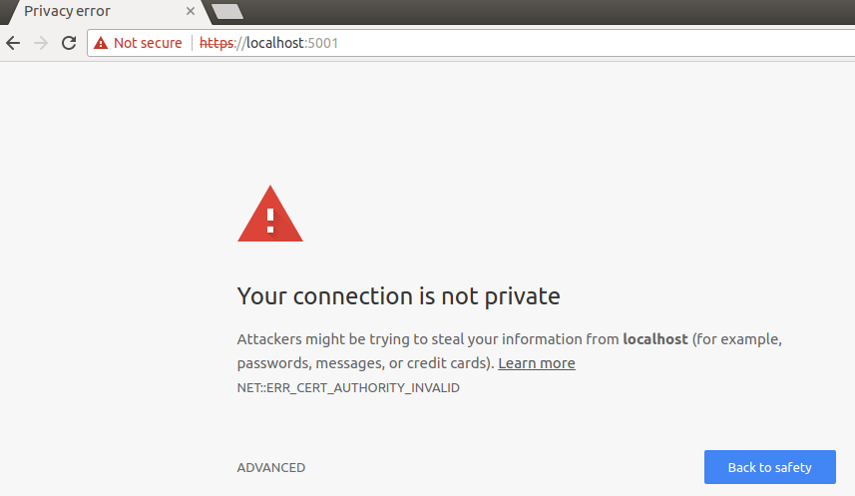

To trust the generated certificate on Windows you need to add it to the current user’s trusted root store:

1. Run *certmgr.msc*
2. Find the certificate under Personal/Certificates. The “Issued To” field should be localhost and the “Friendly Name” should be HTTPS development certificate

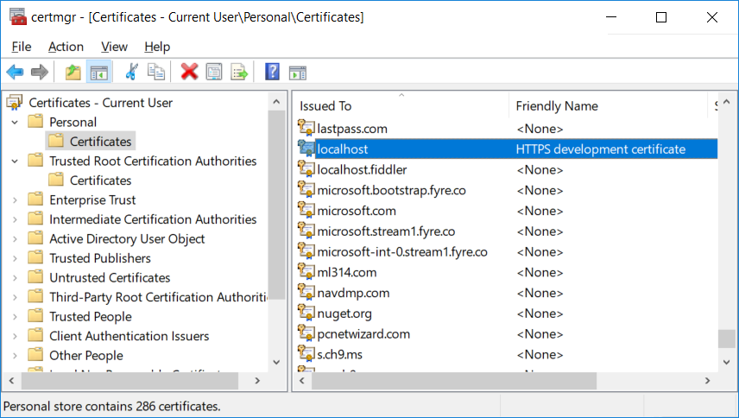

1. Copy the certificate and paste it under Trusted Root Certification Authorities/Certificates
2. When Windows presents a security warning dialog to confirm you want to trust the certificate, click on “Yes”.

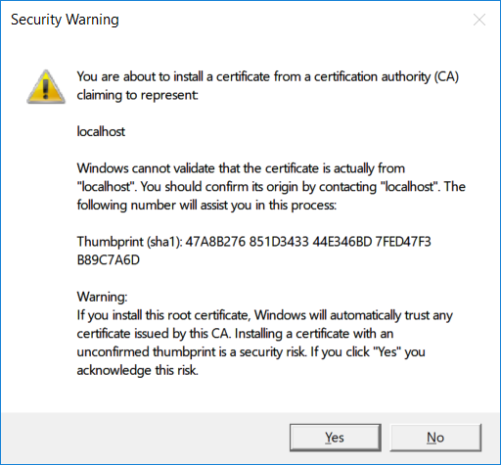

### **Windows Sample Configuration**

To configure your endpoints and HTTPS settings on Windows you could then put the following into your appsettings.Development.json, which configures an HTTPS endpoint for your application using a certificate in a certificate store:

{

"HttpServer":{

"Endpoints":{

"Http":{

"Host": "localhost",

"Port": 8080,

"Scheme": "http"

},

"Https":{

"Host": "localhost",

"Port": 44340,

"Scheme": "https",

"StoreName": "My",

"StoreLocation": "CurrentUser"

}

}

}

}